**Lab Report # 03**



**CSE301 - L Signals & Systems Lab**

Submitted by: AWAIS SADDIQUI

Registration No: 21PWCSE1993

Class Section: “A”

Submitted to:

**Dr. Durr-e-Nayab**

**Department of Computer System Engineering**

**UET Peshawar**

**301L: Signals & Systems Lab**

**LAB ASSESSMENT RUBRICS**

|  |  |  |  |  |
| --- | --- | --- | --- | --- |
| **Marking Criteria** | **Exceeds expectation (5-4)** | **Meets expectation** **(3-2)** | **Does not meet expectation (1)** | **Score** |
| **1. Realization of Experiment** | Program compiles (noerrors and no warnings).  Program always works correctly and meets the specification(s).  Completed between 71-100% of the requirements. | Program compiles (no errors and some warnings).  Some details of the program specification are violated, program functions incorrectly for some inputs.  Completed between 41-70% of the requirements. | Program fails to or compile with lots of warnings.  Program only functions correctly in very limited cases or not at all.  Completed less than  40% of the requirements. | 30% |
| **2. Ability to apply required code utility or data structure** | Able to apply required data type or data structure and produce correct results. Familiarize and selects proper functions for simulation of given problem using  software tools like  MATLAB. | Able to apply required data type or data structure but does not produce correct results. Need guidance to select proper functions for simulation of given problem using  software tools like  MATLAB. | Unable to identify required data type or data structure.  Incapable of selecting proper functions for simulation of given problem using software tools like MATLAB. | 20% |
| **3. Documentation** | Clearly and effectively documented including descriptions of all variables/functions. Specific purpose is noted for each function, control structure, input requirements and output results. | Basic documentation including descriptions of all variables/functions. Specific purpose is noted for each function and control structure. | No documentation included. | 10% |
| **4. Ability to run/debug** | Executes Matlab codes without errors, excellent user | Executes Matlab codes without errors.  User prompts are | Does not execute Matlab codes due to errors. | 20% |

|  |  |  |  |  |
| --- | --- | --- | --- | --- |
|  | prompts, good use of symbols, spacing in output.  Thorough and organized testing has been completed and output from test cases is included. | understandable, minimum use of symbols or spacing in output.  Some testing has been completed. | User prompts are misleading or nonexistent.  No testing has been completed. |  |
| **5. Results compilation** | Show processed results effectively by conducting simple computations and plotting using collected data | Show processed results effectively by conducting simple computations and plotting using collected data with minor error | Unable to show processed results effectively by conducting simple computations and plotting using collected data with minor error | 10% |
| **6. Efficiency** | Excellent use of CPU and Memory. | Good but not smart use of CPU and Memory. | Inefficient use of CPU and Memory. | 10% |
| **7. Lab**  **Performance (Team work and Lab**  **etiquettes)** | Actively engages and cooperates with other group members in an effective manner. Respectfully and carefully observes safety rules and procedures | Cooperates with other group members in a reasonable manner. Observes safety rules and procedures with minor deviation. | Distracts or discourages other group members from conducting the experiment. Disregards  safety rules and procedures. | 10% |

**Instructor:**

Name: _________________________

Signature: ______________________

**Signals & Systems Laboratory**

**MAKING FUNCTIONS:**

A function is a reusable piece of code that can be called from program to accomplish some specified functionality. A function takes some input arguments and returns some output. To create a function that adds two numbers and stores the result in a third variable

**Script Vs Function:**

A script is simply a collection of Matlab commands in an m‐file. Upon typing the name of the file (without the extension), those commands are executed as if they had been entered at the keyboard. Functions are used to create user‐defined Matlab commands.

**Objectives of the Lab:**

* Making Functions
* Control Structures
* Relational Constructs
* Logical Constructs
* Branching Constructs
* Looping constructs

**Task 01:**

Write a function that accepts temperature in degrees F and computes the corresponding value in degrees C.

**Code:**

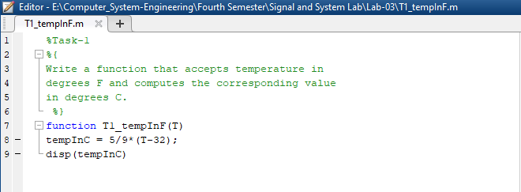

**Output:**

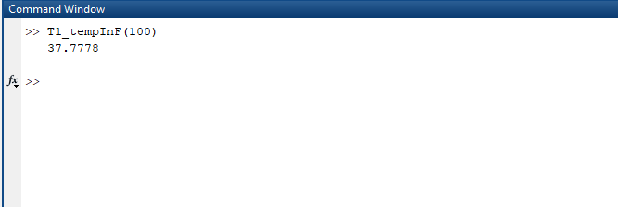

**Task 02:**

For the arrays x and y given below, write matlab code to find all the elements in x that are greater than the corresponding elements in y.

**Code:**

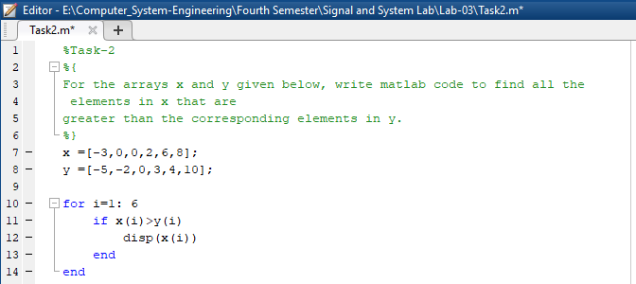

**Output:**

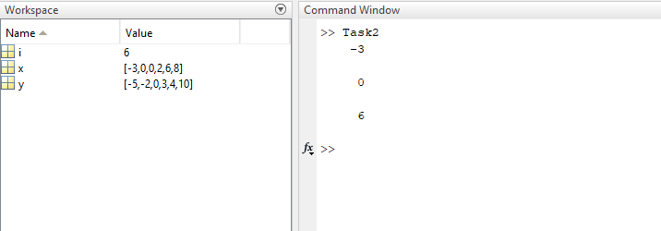

**Task 03:**

For 0 < a ≤ 16, find the values of C

**Code:**

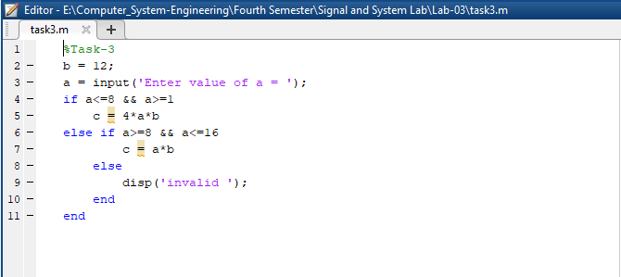

**Output:**

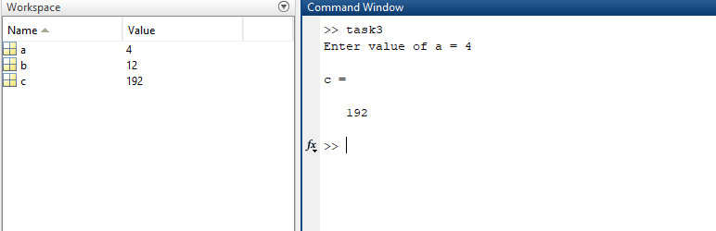

**Task 04:**

For the values of integer a going from 1 to 10, using separately the methods of if syntax and the Boolean alternative expressions, find the values of C if:

**Code:**

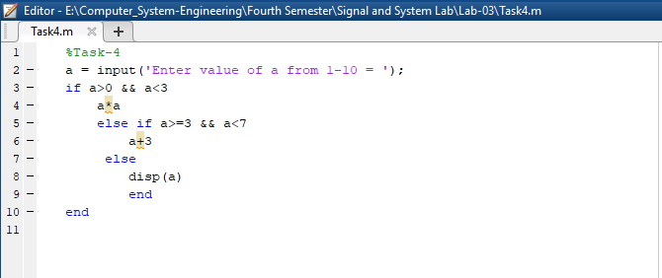

**Output:**

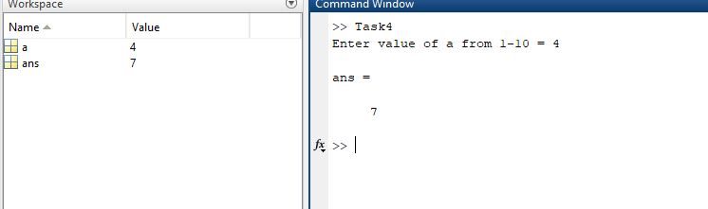

**Task 05:**

Rewrite the following statements to use only one if statement

**Code:**

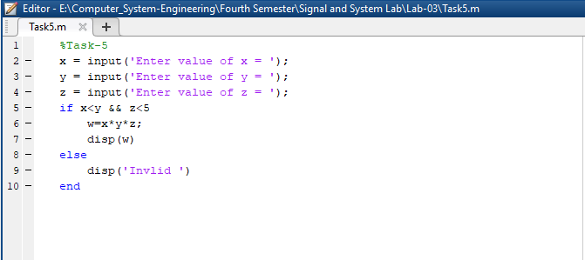

**Output:**

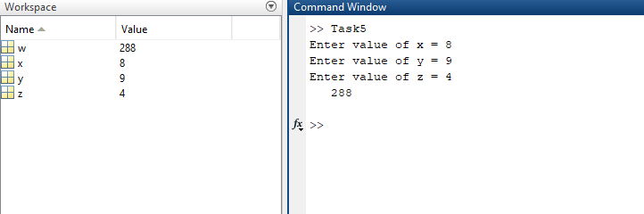

**Task 06:**

Using for loop, generate the cube of the first ten integers

**Code:**

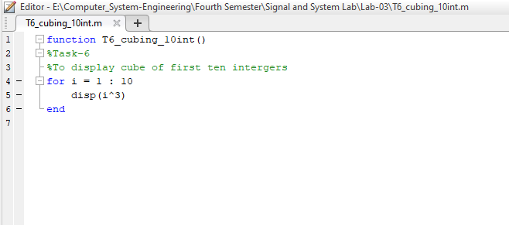

**Output:**

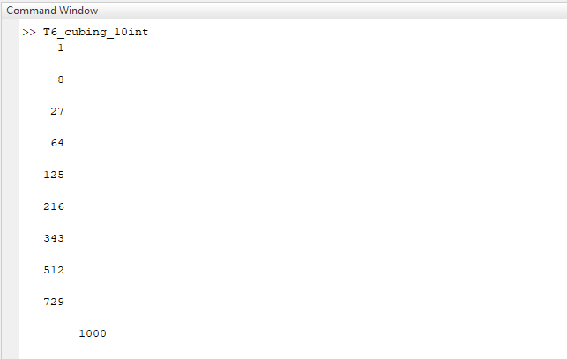

**Task 07:**

Add the following two matrices using for loop.

**Code:**

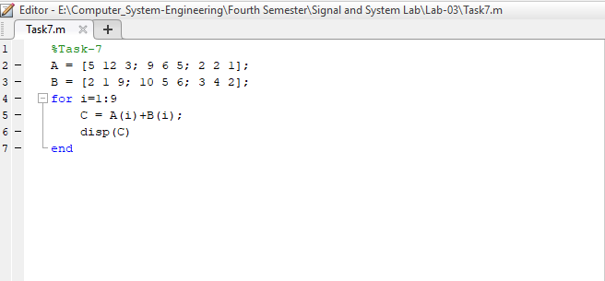

**Output:**

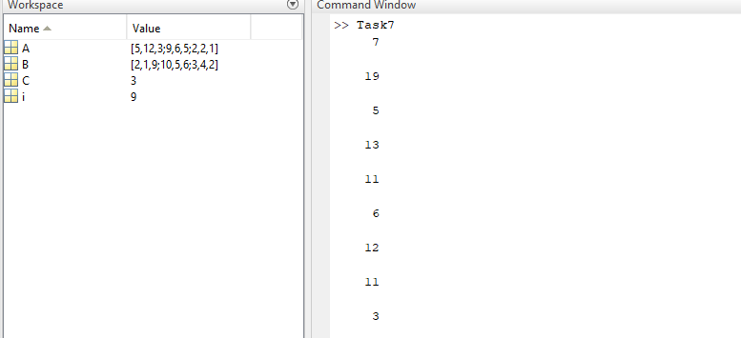

**Task 08:**

Write MATLAB function that creates a special square matrix that has ones in the first row and first column, and whose remaining elements are the sum of two elements i.e. the element above and the element to the left, if the sum is less than 20. Otherwise, the element is the maximum of those two element values

**Code:**

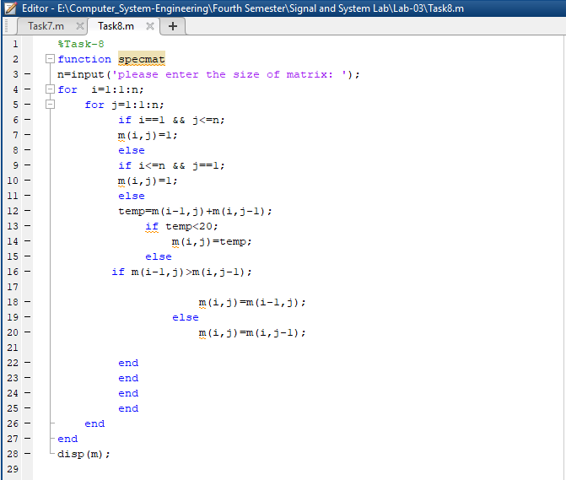

**Output:**

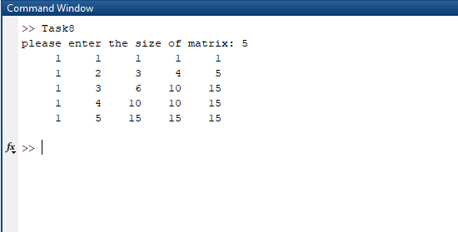

**Task 09:**

Consider the following script file. Fill in the lines of the following table with the values that would be displayed immediately after the while statement if you ran the script file. Write in the values the variables have each time the while statement is executed. You might need more or fewer lines in the table. Then type in the file, and run it to check your answers.

**Code:**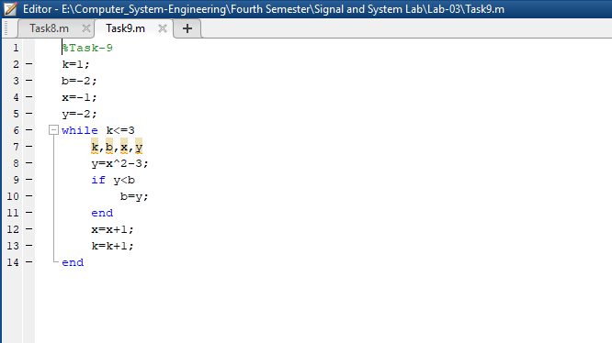

**Output:**

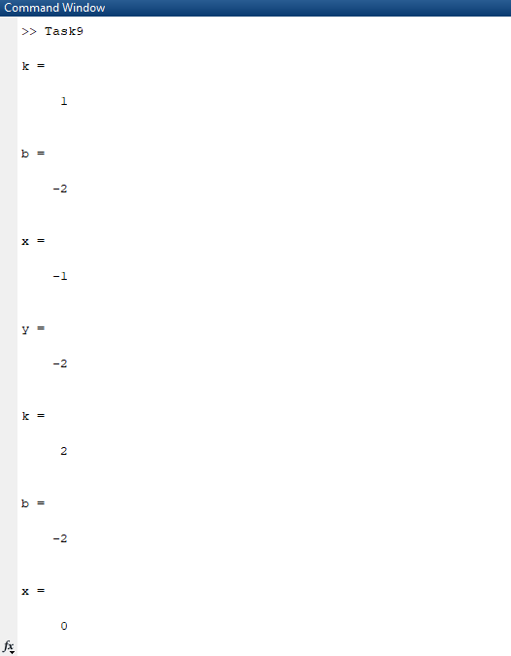

**Task 10:**

Create an m‐file that inputs a number from user and then finds out the factorial of that number. **Code:**

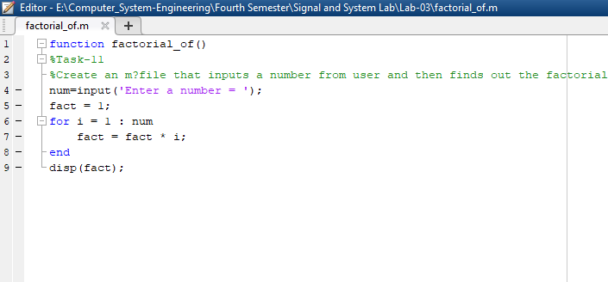

**Output:**

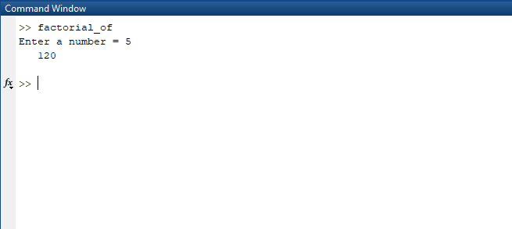

**Task 11:**

Create an m‐file that takes two vectors from user. Make sure that the second vector taken is of the same size as the first vector (Hint: use while loop). In a while loop, generate a third vector that contains the sum of the squares of corresponding entries of both the vectors.

**Code:**

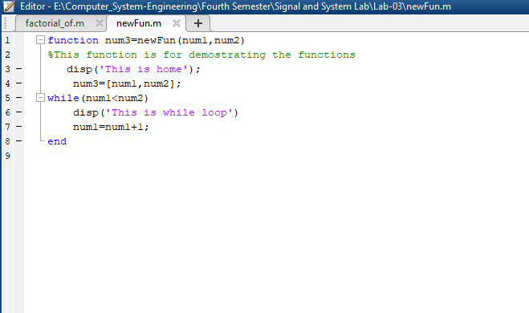

**Output:**

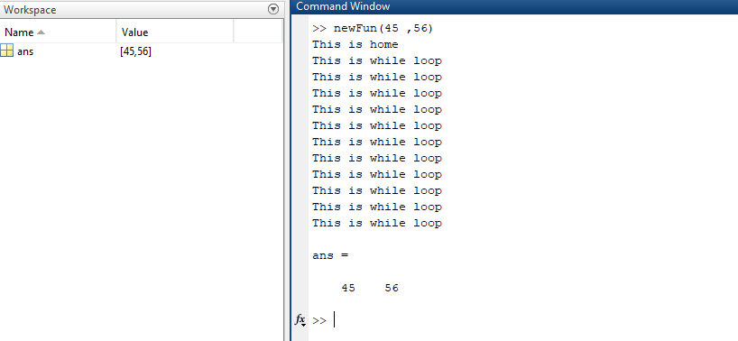

**Task 12:**

**Code:**

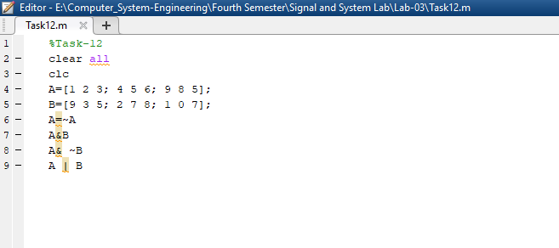

**Output:**

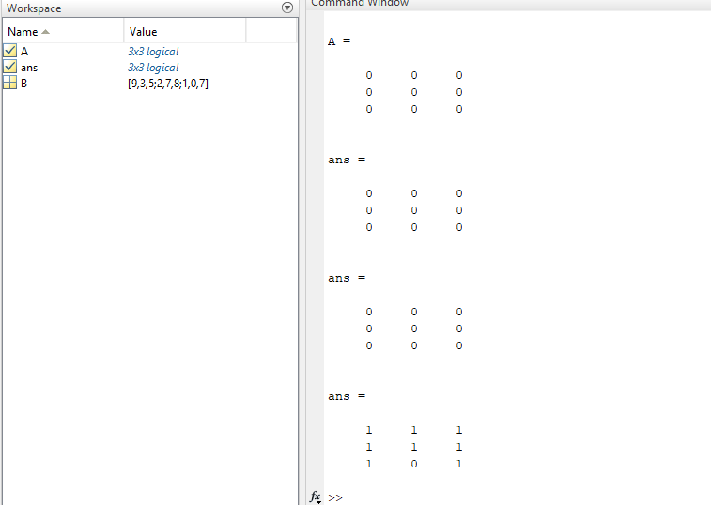

**Task 13:**

Design a function Fib(N) that takes N as an input and generates a Fibonacci sequence for N. Fibonacci sequence is a tile of squares whose side lengths are successive or each number is the sum of the previous number.

**Code:**

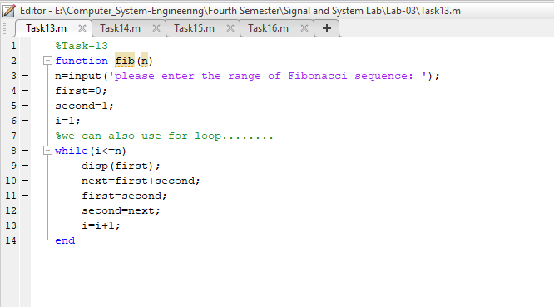

**Output:**

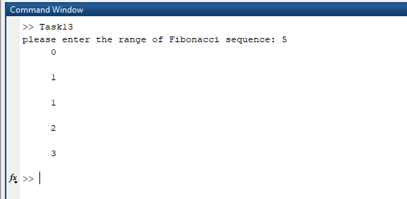

**Task 14:**

Write a user-defined MATLAB function “Calculate”, with two input and two output arguments that determines the height in centimeters (cm) and mass in kilograms (kg) of a person from his height in inches (in.) and weight in pounds

**Code:**

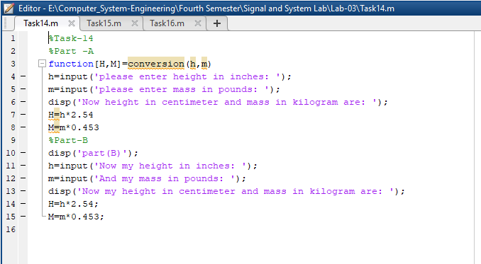

**Output:**

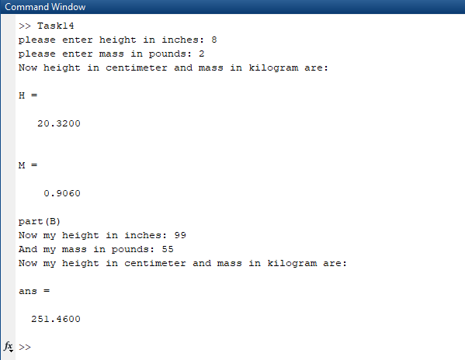

**Task 15:**

File handling in MatLab. Create files of different formats in MatLab. Use the following commands to create a text file using MatLab commands

**Code:**

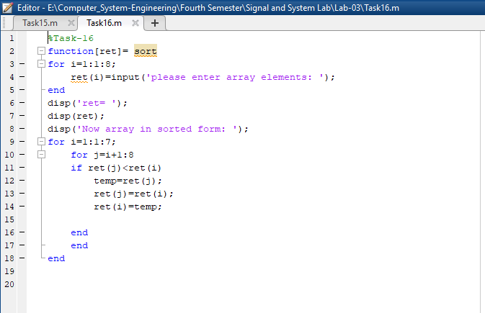

**Task 16:**

Implement any Sorting and Searching algorithm of your choice by creating user-defined functions in MatLab.

**Code:**



**Output:**

